Module 4 answers by User35 (Othman Emara)

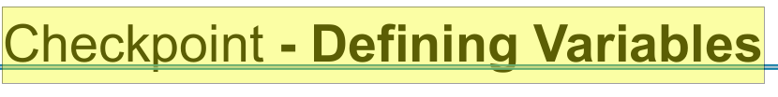

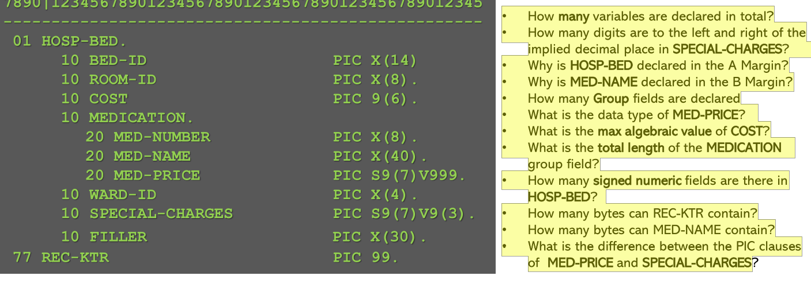

•How y many variables are declared in total? 9 this include all fields with Pic clause (except FILLER) .

• How many digits are to the left and right of the implied decimal place in SPECIAL- CHARGES?

7 to left with 3 decimal places

• Why is HOSP- - BED declared in the A Margin? 01 and 77 data items must be declared in the A magin .

• Why is MED- NAME declared in the B Margin? It’s level number (20) is other than 01 / 66/77/88 so it’s place should be B margin .

• How many Group fields are declared ? two (HOSP-BED & Medication - those with no pic clause)

• What is the data type of MED- PRICE? Signed numeric

• What is the max algebraic value of COST? 999999

• What is the total length of the MEDICATION group field?

8 + 40 + 10 = 58 (is there extra byte for the sign of med-price?)

• How many signed numeric fields are there in HOSP- BED? two

• How many bytes can REC-KTR contain? two

• How many bytes can MED-NAME contain? 40

• What is the difference between the PIC clauses of MED-E PRICE and SPECIAL-charges? No difference.

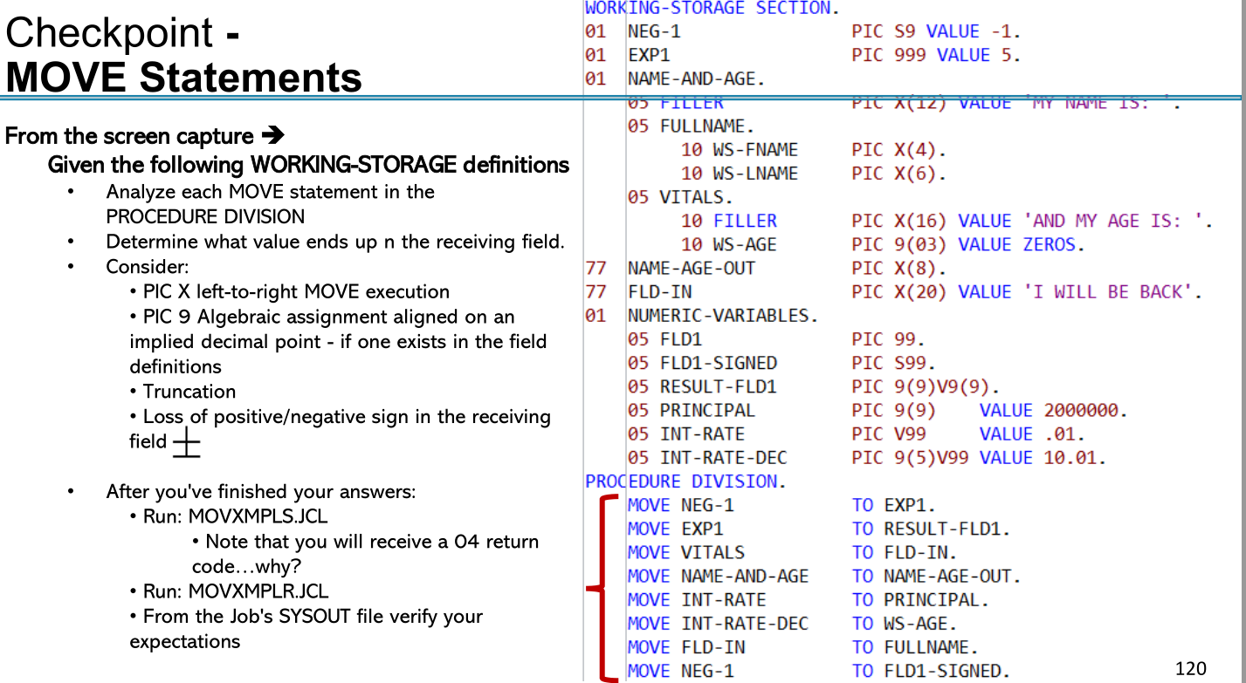

IDENTIFICATION DIVISION.

PROGRAM-ID. MOVXMPLN.

DATA DIVISION.

WORKING-STORAGE SECTION.

01 NEG-1 PIC S9 VALUE -1.

01 EXP1 PIC 999 VALUE 5.

77 WS-AGE PIC 9(03) VALUE ZEROS.

01 NUMERIC-VARIABLES.

05 FLD1 PIC 99.

05 FLD1-SIGNED PIC S99.

05 RESULT-FLD1 PIC 9(9)V9(9).

05 PRINCIPAL PIC 9(9) VALUE 2000000.

05 INT-RATE PIC V99 VALUE .01.

05 INT-RATE-DEC PIC 9(5)V99 VALUE 10.01.

05 FLD2 PIC 9(3)V99 VALUE 23.6.

05 FLD2-OUT PIC $$9.99.

05 FLD3 PIC 9(5)V99 VALUE 0002131.

05 FLD3-OUT PIC $ZZ,ZZ9.99.

05 FLD4 PIC 9(6)V99 VALUE 876543.21.

05 FLD4-OUT PIC $\*\*,\*\*\*.99.

05 FLD5 PIC 9(7)V99 VALUE 234.56.

05 FLD5-OUT PIC $$9,999.9.

05 FLD6 PIC S9(3)V99 VALUE -123.4.

05 FLD6A-OUT PIC -\*,\*\*\*.99.

05 FLD6B-OUT PIC \*,\*\*\*.99-.

05 FLD7 PIC S9999 VALUE -1234.

05 FLD7-OUT PIC -ZZZ,ZZ9.

05 FLD8 PIC S9(5)V99 VALUE 0000.

05 FLD8-OUT PIC $9,999.99 BLANK WHEN ZERO.

05 FLD9 PIC 9999.

05 FLD9-OUT PIC -Z,ZZ9.

\*

PROCEDURE DIVISION.

PERFORM MOVE-STATEMENTS.

PERFORM DISPLAY-RESULTS.

GOBACK.

\*

MOVE-STATEMENTS.

MOVE NEG-1 TO EXP1. (Sign lose & EXP1 is now Positive!!)

MOVE EXP1 TO RESULT-FLD1.

MOVE INT-RATE TO PRINCIPAL. (mis match between the two fields PRINCIPAL have no decimal positions )

Compiler also detected the mismatch.

42 IGYPA3087-W "INT-RATE (NUMERIC NON-INTEGER)" and "PRINCIPAL (NUMERIC INTEGER)" had no digit positions in common. The receiver will be set to zero at execution time.

Messages Total Informational Warning Error Severe Terminating

Printed: 1 1

MOVE INT-RATE-DEC TO WS-AGE. (mis match / data loss)

MOVE NEG-1 TO FLD1-SIGNED.

MOVE FLD2 TO FLD2-OUT.

MOVE FLD3 TO FLD3-OUT.

MOVE FLD4 TO FLD4-OUT.

MOVE FLD5 TO FLD5-OUT.

MOVE FLD6 TO FLD6A-OUT, FLD6B-OUT.

MOVE -1234.99 TO FLD7.

MOVE FLD7 TO FLD7-OUT.

MOVE FLD8 TO FLD8-OUT.

MOVE -1234 TO FLD9.

MOVE FLD9 TO FLD9-OUT.

\* Note that the - (minus sign) in FLD9-OUT consumes a blank

DISPLAY-RESULTS.

DISPLAY "EXP1 " EXP1.

DISPLAY "RESULT-FLD1 " RESULT-FLD1.

DISPLAY "PRINCIPAL " PRINCIPAL.

DISPLAY "WS-AGE " WS-AGE.

DISPLAY "FLD1-SIGNED " FLD1-SIGNED.

DISPLAY "FLD2-OUT " FLD2-OUT.

DISPLAY "FLD3-OUT " FLD3-OUT.

DISPLAY "FLD4-OUT " FLD4-OUT.

DISPLAY "FLD5-OUT " FLD5-OUT.

DISPLAY "FLD6A-OUT " FLD6A-OUT.

DISPLAY "FLD6B-OUT " FLD6B-OUT.

DISPLAY "FLD7-OUT " FLD7-OUT.

DISPLAY "FLD8-OUT " FLD8-OUT "END OF FLD8-OUT".

DISPLAY "END".

The resuls as

EXP1 001

RESULT-FLD1 000000001000000000

PRINCIPAL 000000000

WS-AGE 010

FLD1-SIGNED =>0J

FLD2-OUT 02360=>$23.60

FLD3-OUT 0213100=>$ 2,131.00

FLD4-OUT 87654321=>$76,543.21

FLD5-OUT 000023456=> $0,234.5

FLD6A-OUT 1234}=>-\*\*123.40

FLD6B-OUT 1234}=>\*\*123.40-

FLD7-OUT 123M=>- 1,234

FLD8-OUT 000000{=> (blank when zero !!) END OF FLD8-OUT

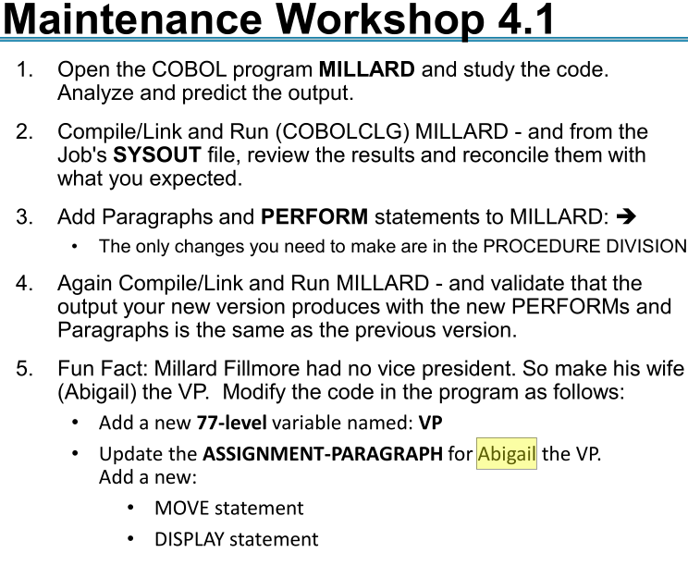

Answer in next page.

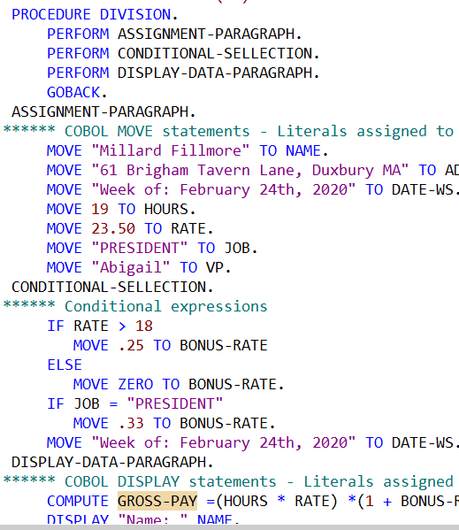

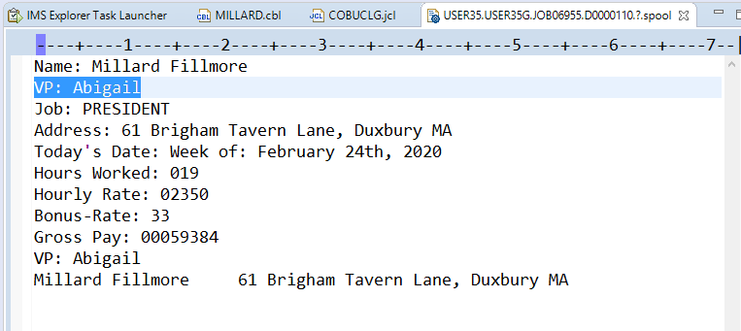

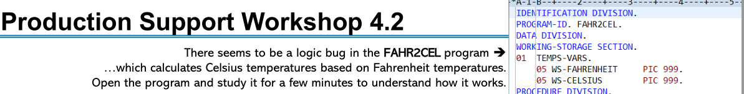

Need to enlarge the celluses by one digit to avoid truncation .

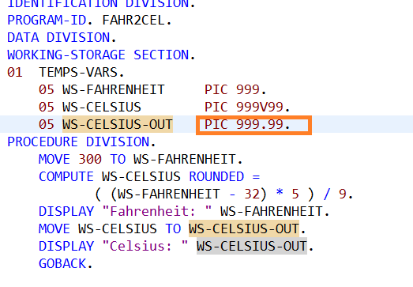

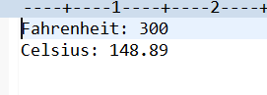

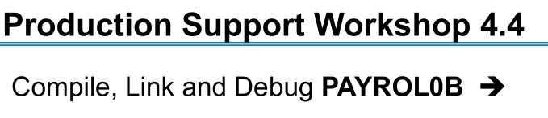Answer

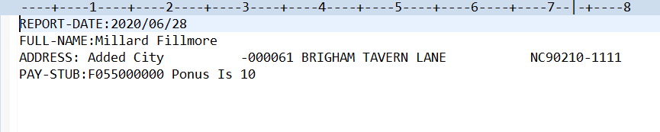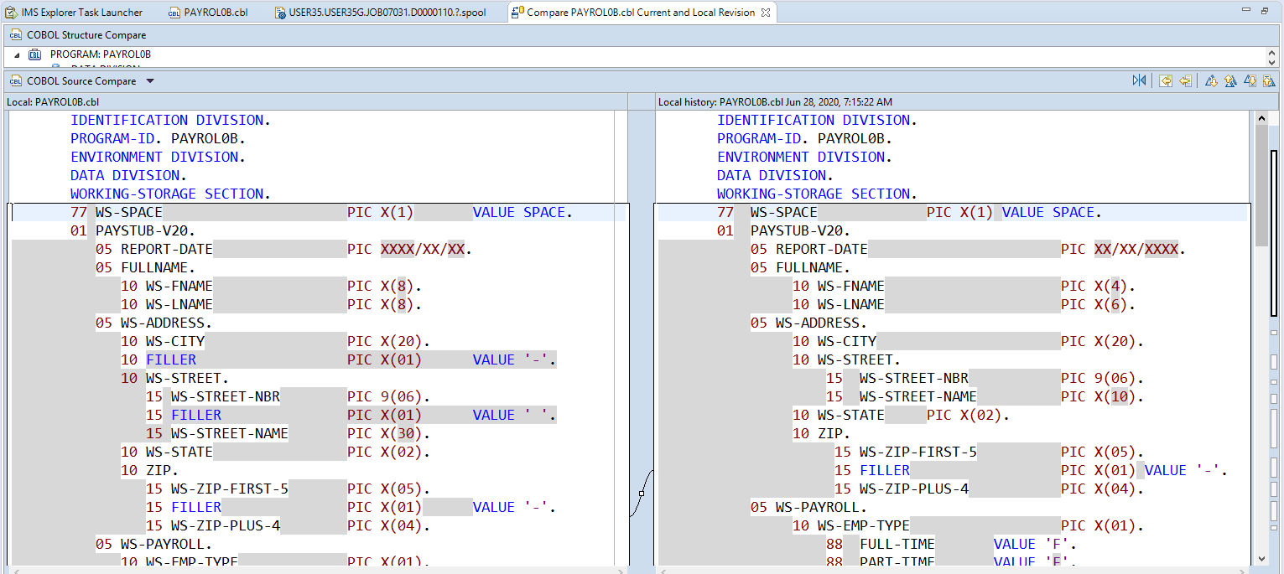

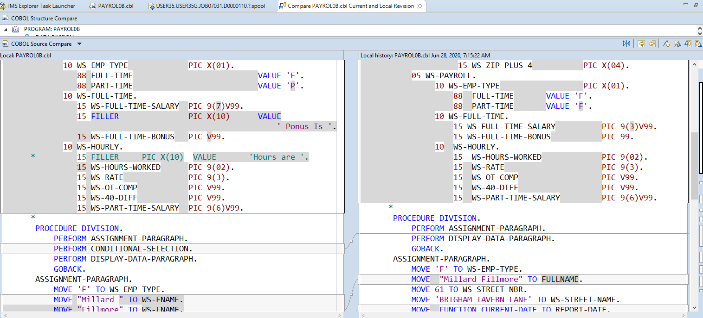

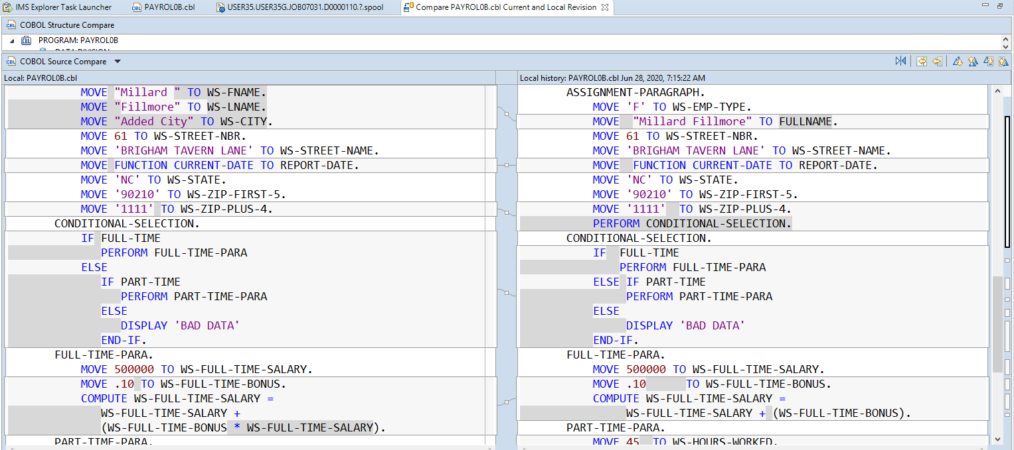

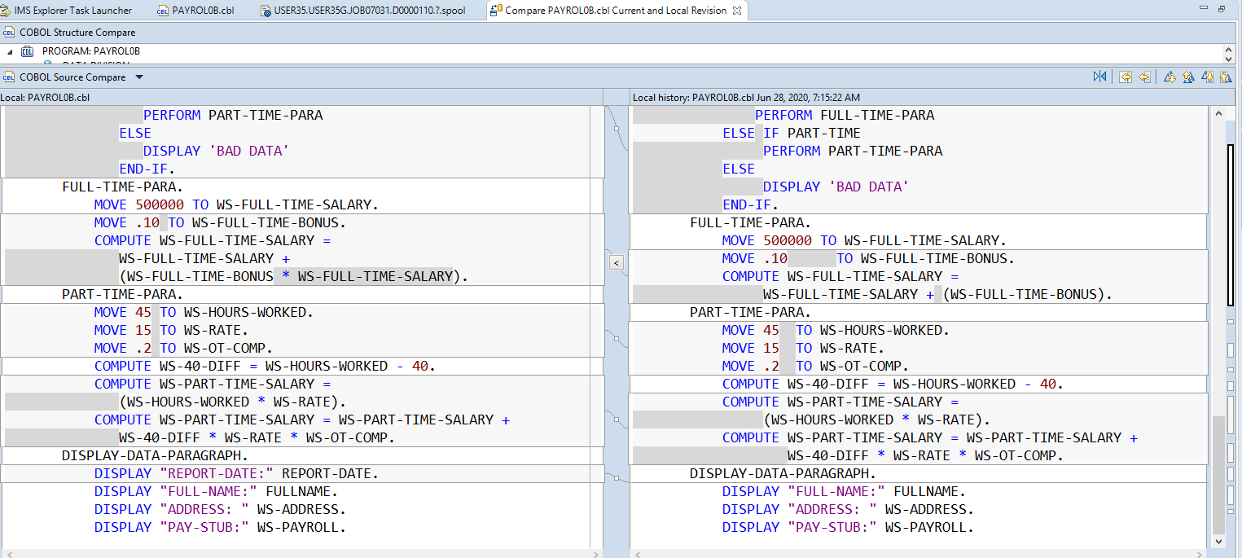

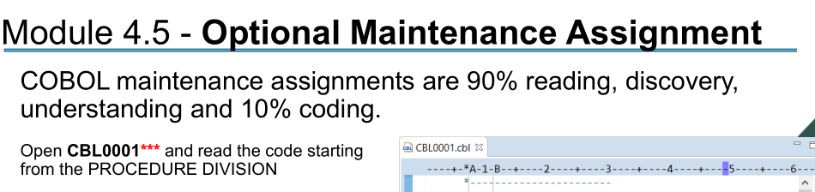

Answer : Sure , understand and also modified (by adding columns heading )

